Customer Journey & Conversion Analytics
Dataset Overview
Rows: 12,330
Columns: 18
FOR A/B testing we will take the parameter ‘Weekend’
Weekend: 0 weekday | | Weekend:1 weekend
Phase 1: Business Understanding
- What drives purchases?
- Which traffic sources convert best?
- Which months perform best?
- Does weekend traffic convert better?
- Which visitor types generate the highest revenue?
- How does engagement affect conversions?
- Can we predict whether a visitor will purchase?
Phase 2: SQL Project
Create a SQL database
Creating the Table
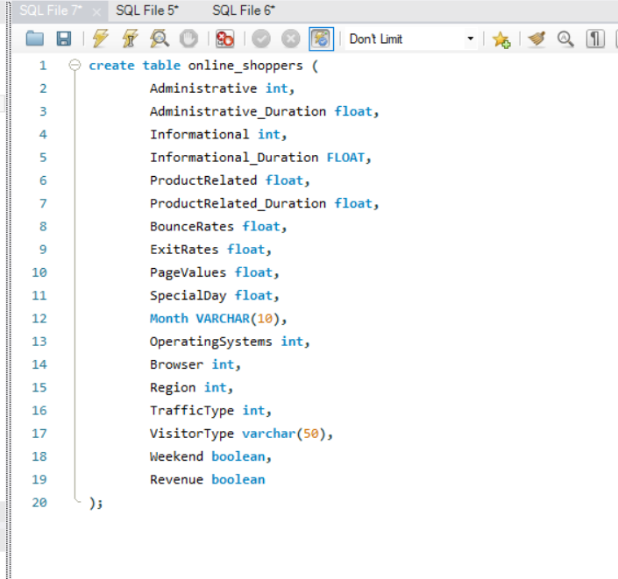
1. Overall Conversion Rate
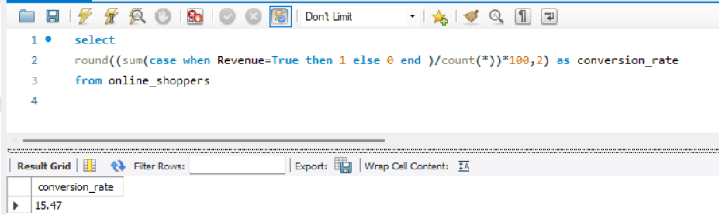

2. Conversion by Month
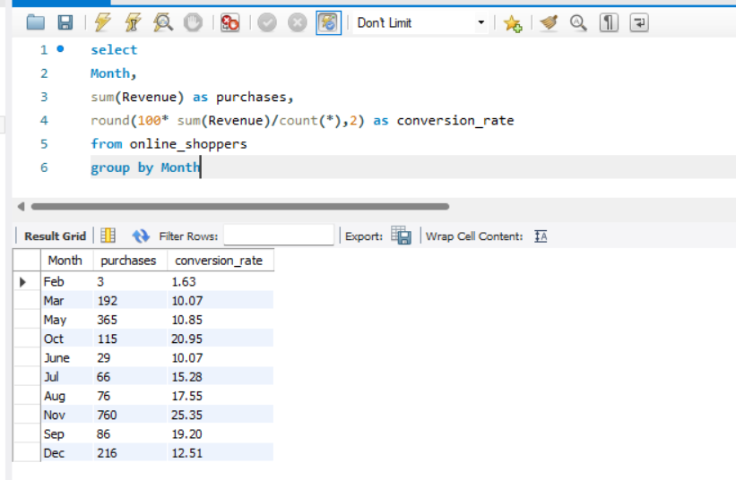
3. Conversion by Visitor Type
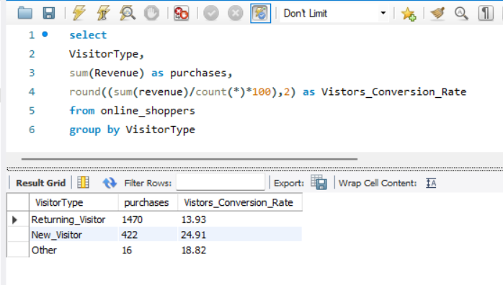
4. Weekend vs Weekday
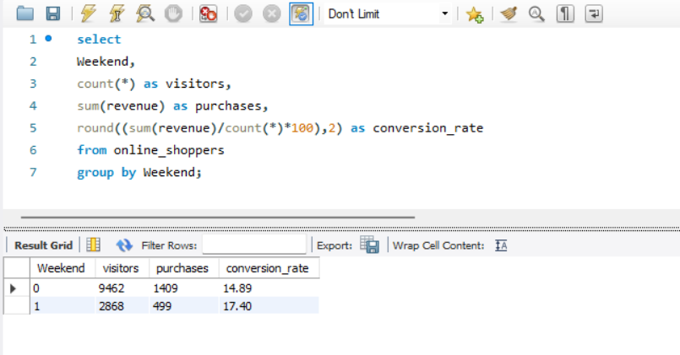

5. Best Traffic Sources
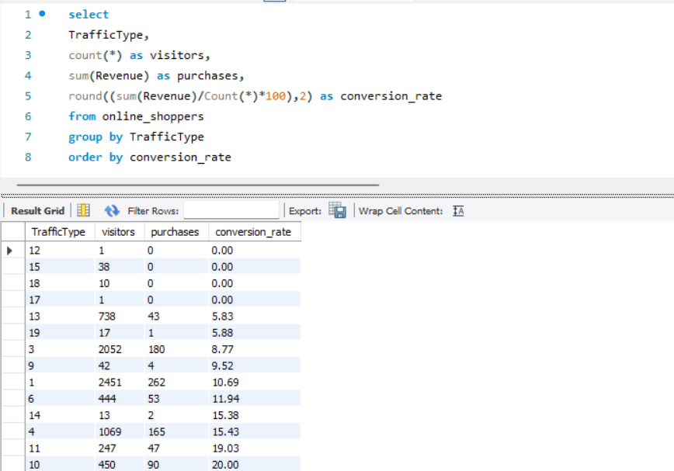

6. Monthly Revenue Contribution
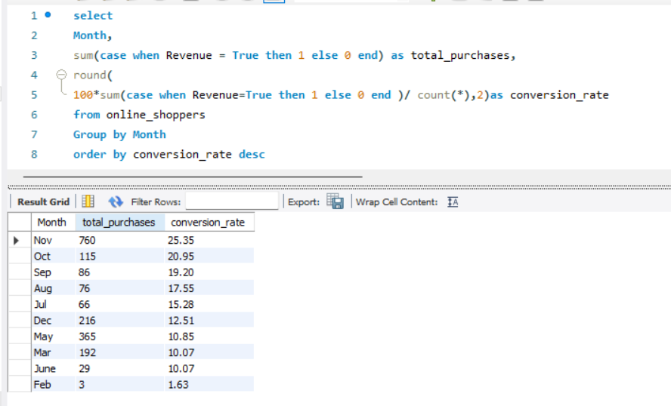
7. Returning vs New Visitor Performance
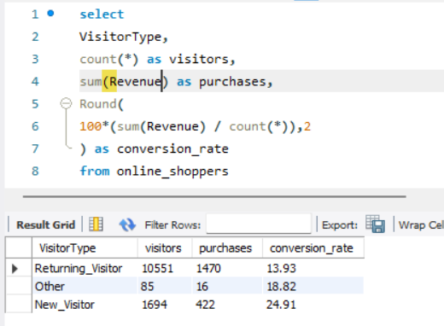
8. Which Browser Converts Best?
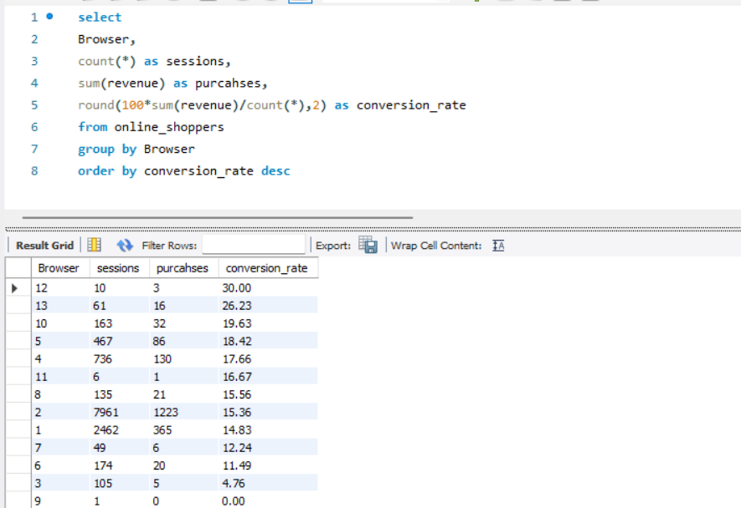
9. Operating System Analysis
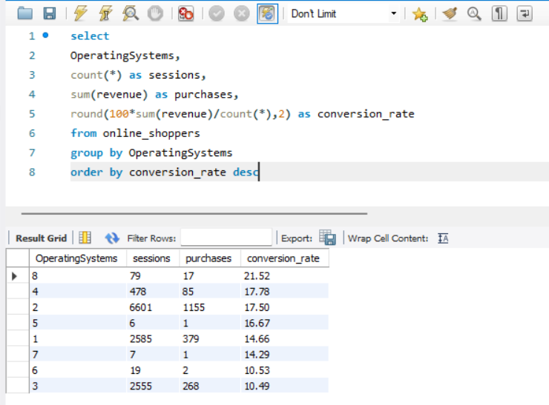
10.Region Wise Conversion Rate
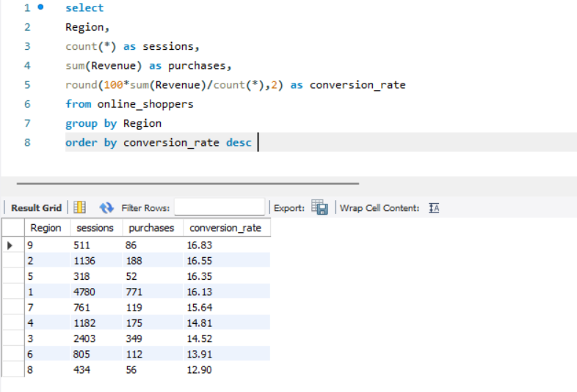
Important Metrics in this Dataset
- Product Related
- Product Related Duration
- Bounce Rate
- Exit Rate
- Page Value

11.Product Related
Number of Product Related Pages Visited during the Sessions
- How many product related pages did the user view
Do users who view more products convert better? Yes
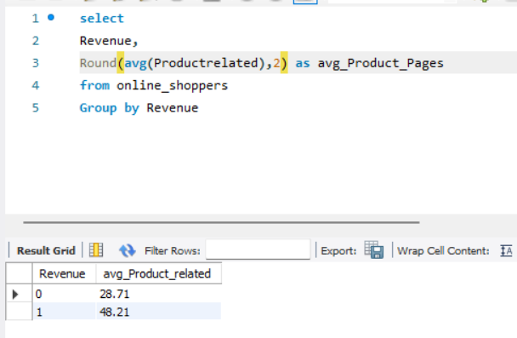
Higher Value means:
- Strong Engagement
- Product Comparisons
- Research Before Buying
- Higher Purchase Intent

12.Product Related Duration
Total Time in second that the users spend on a Product related page
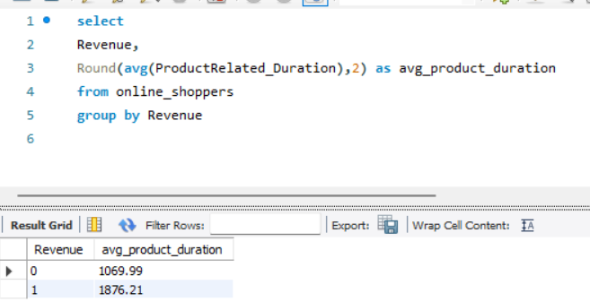
- Higher value means:
  - Strong Purchase intention
  - User researching Product
  - User comparing option
- Lower value means:
  - Low Engagement
  - Visitor not interested

13.Bounce Rate
The Percentage of session where the user enters and leaves without meaningful interaction
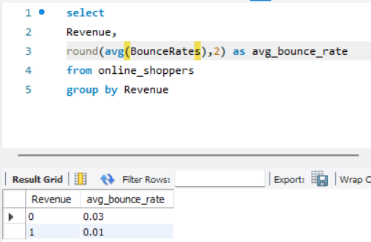
Values: 0.01 = 1%
0.20=20%
0.50=50%
Higher Bounce Rate Lower Bounce Rate
- Bad Landing Page Engaged user
- Irrelevant Traffic Better Quality Traffic
- Poor User Experience Good User Experience
Purchaser 0.01 = 1% Purchaser Explored.
Non-Purchaser 0.03 = 3% Non-Purchaser Left Quickly.
14.Exit Rates
The percentage of page views that ended with users leaving the website from that page.
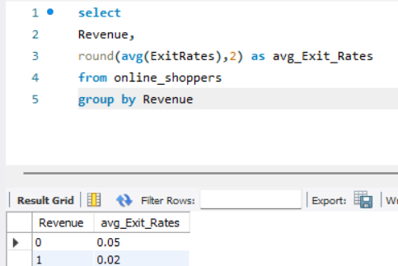
Higher Exit Rate Low Exit Rate
- Confusing Page User continue Deeper into funnel
- Price Shock
- Check-out Issue
- Lack of Information

15.Page Value
A Score representing how valuable that page is.
- Pages closure to conversion receives a higher value
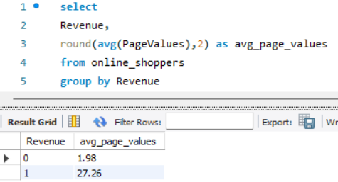

Higher Page Value Low Page Value
- Strong Buying intent Casual Browsing
- User Closure to Conversion Low Commercial intent
Customer Segmentation
16. Engagement Segmentation
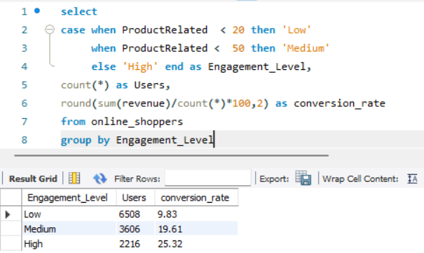
17.Session Segmentation
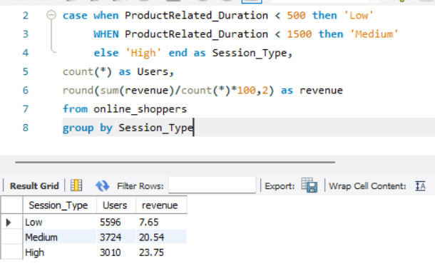
18.Bounce Rate Segmentation
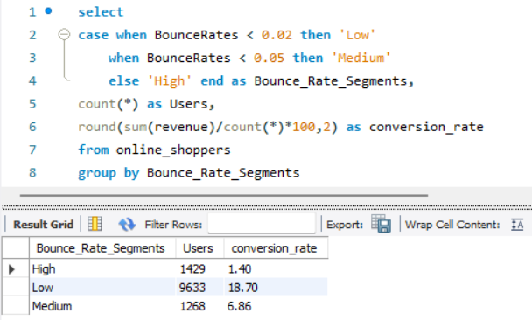
19.Best Traffic Type
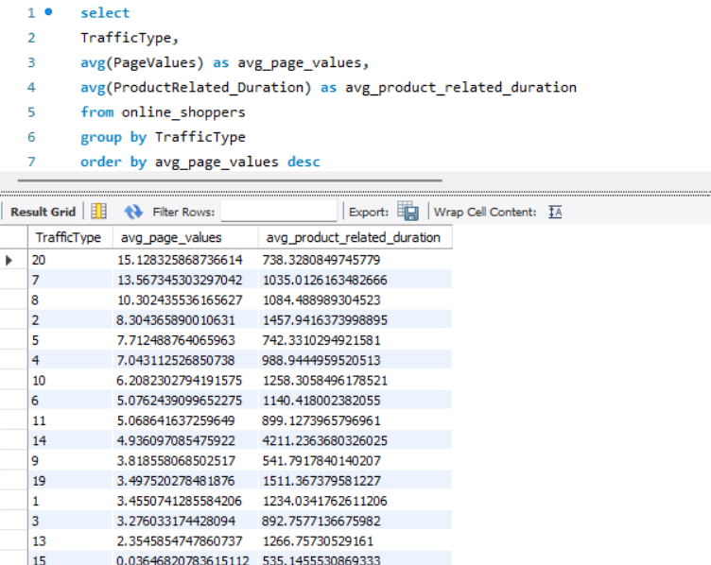
Funnel Analytics
Funnel Stage Analysis
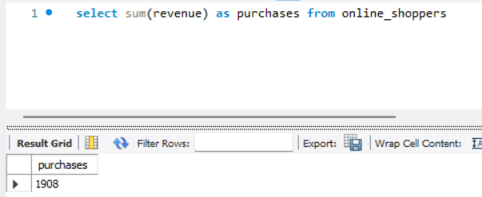
Total Number of Purchases = 1908
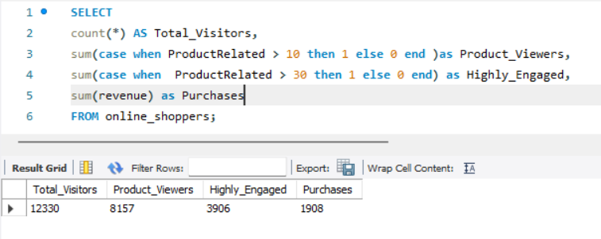

Funnel Conversion %
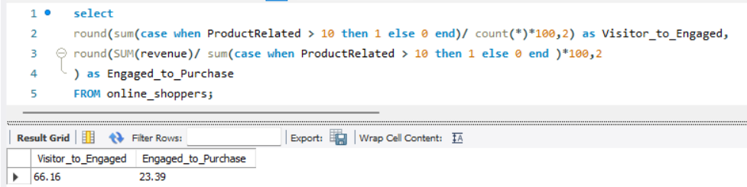

Month-over-Month Conversion Change
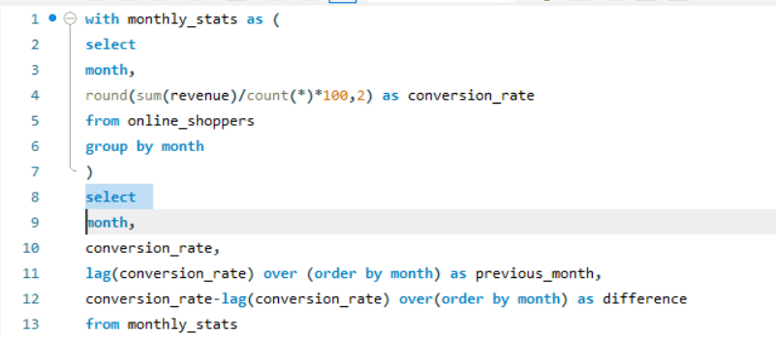
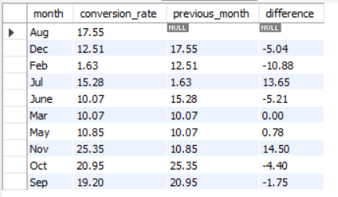

For A/B Testing we are targeting:
WEEKEND factor where:
WEEKEND = 0 = False Weekdays
WEEKEND = 1 = True Weekend
To Test the hypothesis that:
The purchases are done more on the weekends than the weekdays
Null Hypothesis: {Ho} = (Conversion Rate)_{weekend} = (Conversion Rate)_{weekday}
i.e.: There is no difference between the Conversion between weekend and weekday
Alternate Hypothesis: {H₁} (Purchase)_{weekend} > (Purchase)_{weekday}
i.e.: There is a significant difference between the conversion due to purchases carried out on the weekends than the weekdays
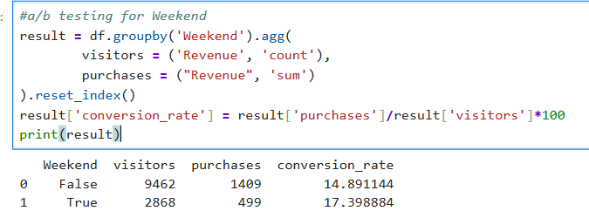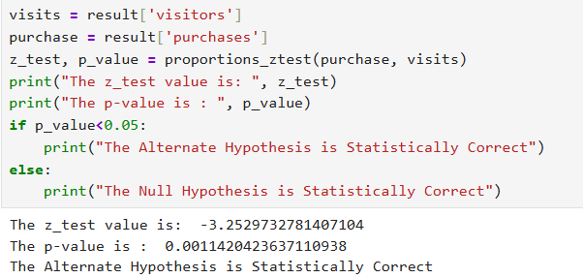

Similarly, for:
- VisitorType:
Null Hypothesis: {Ho}(Conversion Rate)_{NewVisitors} = (Conversion Rate)_{ReturningVistors}
i.e.: Conversion of New Visitors is same as Returning Visitors
Alternate Hypothesis: {H₁} (Purchase)_{NewVisitors} > (Purchase)_{ReturningVisitors}
i.e.: Conversion of New Visitors is more than Returning Visitors

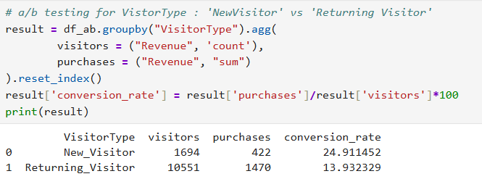
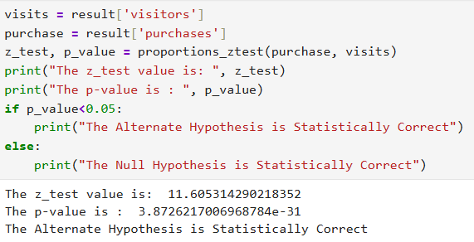
For High vs Low Product Related(Pages):
Null Hypothesis: {Ho}( Conversion Rate)_{High}= (Conversion Rate)_{low}
i.e.:Conversion due to high Product Related is same as Low
Product related pages
Alternate Hypothesis: {H₁}}( Conversion Rate)_{High}>( Conversion Rate)_{low}
i.e.: due to high Product Related is more than as Low Product related pages
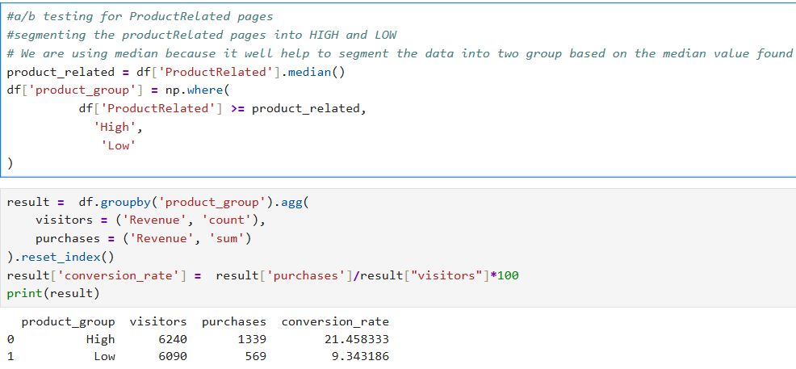
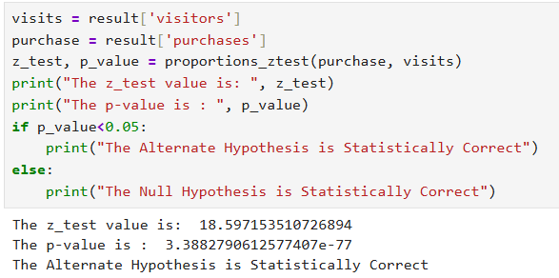

High vs Low ProductRelatedDuration
Null Hypothesis: {Ho}(Conversion Rate)_{High}= (Conversion Rate)_{low}
i.e.: Purchases/ Conversion due to high Product Related Duration is same as Low Product Related Duration of Product related pages
Alternate Hypothesis: {H₁}}( Conversion Rate)_{High} > (Conversion Rate)_{low}
i.e.: Purchases/ Conversion due to high Product Related Duration is more than as Low Product related Duration
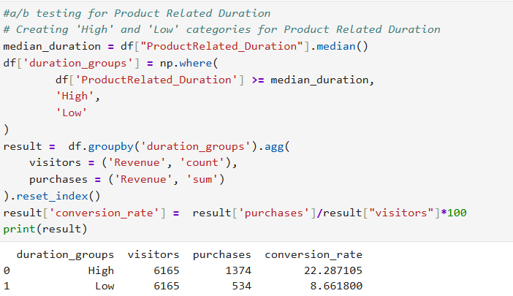
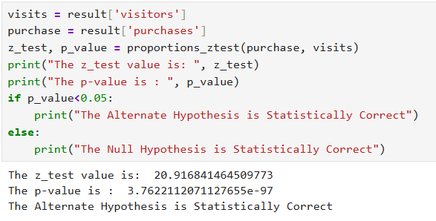
High vs Low Bounce Rate
Null Hypothesis: {Ho}(Conversion Rate)_{High}= (Conversion Rate)_{low}
i.e.: Purchases/ Conversion due to high Bounce Rate is same as Low Bounce rate
Alternate Hypothesis: {H₁}}( Conversion Rate)_{High} <(Conversion Rate)_{low}
i.e.: Purchases/ Conversion due to high Bounce Rate is less than Bounce Rate

